Part 1

1. **“Good” text pdf (Include in canvas submission)**
2. Attached.
3. **“Bad” text pdf (Include in canvas submission)**
4. Attached.
5. **Screenshot of the hashes of the text PDFs colliding for SHA1 and differing with SHA512**

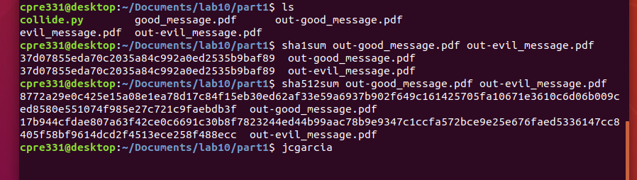

1. **Image out-1.pdf (Include in canvas submission)**
2. Attached.
3. **Image out-2.pdf (Include in canvas submission)**
4. Attached.
5. **Screenshot of the hashes of the image PDFs colliding for SHA1 and differing with SHA512**

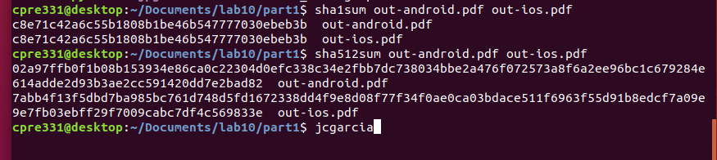

1. **Answer questions in part p**
   * 1. **How likely is this to be used to carry out an attack in the wild?**

**TODO**

Part 2

**1)  Upload your code to canvas as a seperate .py file**

1. Attached.

**2)**  **What is the winning lottery number for November 12th, 2022?**

1. Assuming the numbers for the 11th are 5-4-3-1-2-9-1-4-2-5, we use our program to match the seed. Once our seed is matched, we find that our numbers for November 12th are 7-3-4-6-4-3-5-8-7-5:

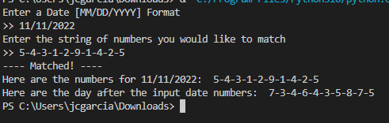

**3) In your own words, what is the seed for this random number generator? Why is this a good or bad thing?** **Justify your answer.**

1. The seed for this generator is the date + the time in seconds of the day. The issue with this seed is that it is not random -